KN Circet, crag avenue, clondalkin, Demolition Waste Management Plan
KN Circet, Clondalkin
January 25, 2022
Hegarty Demolition
Rathfarnham, Co. Dublin

Demolition Waste Management Plan.

Prepared by: Hegarty Demolition Ltd
46 Blackburne Square
Rathfarnham Gate,
Rathfarnham,
Dublin 14
D14 V4F1

Rev 0
Date:25/01/2022

Revision | Date | Compiled by | Signature | Comment
0 | 25/01/2022 | Garreth Brennan

REVIEWS
Revision | Date | Reviewed by | Signature | Comment

REVISION NOTES

Rev 0. For submission to Dublin City Council

Contents of Waste Management Plan:

- Introduction

- Waste Management Policy

- Definition of Waste & Waste Classification

- Waste Arising on Site

- Waste Licences / Permits

- Document Control

- Noise, Dust, Vibration and Wastewater Controls

- Training & Awareness

- Waste Auditing

SECTION 1. INTRODUCTION

The Demolition Waste Management Plan (DWMP) has been prepared to set out the means in which Hegarty Demolition Ltd propose to ensure that all demolition wastes arising from the project are dealt with in a systematic way and in accordance with the governing legislation i.e. The Waste Management Act 1996 and subsequent amendments.
This plan has been prepared in accordance with the “Best Practice Guidelines on the Preparation of Waste Management Plans for Demolition Projects” (Department of Environment, Heritage and Local Government, July 2006).

- Site Location.

The site is KN Circet, Crag Avenue Business Park, Clondalkin, Dublin.

1.2 Works Proposals

Softstrip & Demolition

Works include the following tasks:

1. Site set up
2. Softstripping
3. Removal of Asbestos
4. Demolition
5. Load waste into skips
6. Load waste into Lorries

1.3 Purpose of the Demolition Waste Management Plan

The proposed development Demolition process will generate a significant amount of waste and require the movement of this waste off site. This Demolition Waste Management Plan outlines the approach to demolition waste management, throughout the duration of the project, from demolition right through to completion of the works.

The generation and implementation of a waste management plan is one of the Hegarty Demolition Ltd environmental objectives. The purpose of the Waste Management Plan is to ensure the compliant disposal of all waste generated on site. All wastes and unwanted materials arising from the works shall be disposed of in accordance with this Waste Management Plan and the associated operating procedures.

1.4 Site Contact Details:

Project Manager/Director: Paul Hogan 086-8379776
Site Manager TBC
QHSE Manager Micheal Earley 086-3862196
Waste Coordinator Garreth Brennan 087-2214867

SECTION 2: WASTE MANAGEMENT POLICY

The following waste management strategy shall be applied at all times: -

‘Reduce, Re-use, Recycle’.

Reduce | The prevention or minimisation of waste production when undertaking any activity.
Reuse | The reuse for the same purpose of a used product or material with minimal (if any) processing (e.g. used equipment, reusable packaging, wood, toner cartridges).
Recycle | The use for the same or different purpose of a used product or material which requires processing (e.g. scrap metal, waste oil, paper, cardboard, plastic etc.).

Hegarty Demolition will document and record all waste removed from site. (See waste Log below)

Hegarty Demolition will implement a strategy of waste management from site induction to project completion, reinforcing training through toolbox talks and poster campaigns. The site operatives will be encouraged to minimize the risk of waste pollution either via blown litter or cross contamination of waste streams.

Under no circumstances should any waste materials be burned.

SECTION 3: DEFINITION OF WASTE & WASTE CLASSIFICATION

Waste | Any substances or object belonging to a category of waste specified in the First Schedule (of the Waste Management Act 1996 and amended 2001 regulations) or included in the European Waste Catalogue, WPR 07/06 – Best practice guidelines on the preparation of waste management plans for Demolition Projects – DoEHLG and DCC waste management guidelines which the holder discards or intends or is required to discard and anything which is discarded or otherwise dealt with as if it were waste shall be presumed to be waste until the contrary is proved.
Re-useable/Recyclable Waste | Waste which can be cleanly removed, segregated and re-cycled for potential re uses in the future development of any future proposed development.
Hazardous waste | Wastes which can have a harmful effect on the environment and on human health as they exhibit ignitability, reactivity, corrosivity and/or toxicity and / or are listed as hazardous by the European Waste Catalogue and / or may be identified as hazardous by application of the EPA Waste Characterisation Tool compiled by The Clean technology Centre.
Construction and Demolition residual Waste | Materials resulting from the construction, remodelling, repair, or demolition of buildings and other structures.

For LEED certification purposes, alternative daily cover (ADC) does not qualify as material diverted from disposal. Land-clearing debris is not considered construction, demolition, or renovation waste that can contribute to waste diversion.
Hazardous materials are tracked separately and are not included in the project’s total waste.

SECTION 4: WASTE ARISING ON SITE

Wastes generated on site must be identified and segregated accordingly. In order to enable this, the works will be carried out in phased nature to aid the segregation of the materials expected to be encountered during the works. As materials are being taken down from the interior of the building they will be assessed for reuse. Any reusable materials will be set aside in a designated area of the site for transport to licensed recycling facilities. All non-reusable material will be segregated and disposed of into specific skips located on a designated area of the site.

It is the responsibility of the HSE Advisor or Project Manager to ensure that all waste generated on site (hazardous and non-hazardous) is stored in an appropriately labelled designated container/collection facility. These containers must be fit for purpose to prevent leaks or spills. Waste streams must not be combined for disposal.

A brief overview of the methods to manage the primary waste streams expected is presented below. The main types of construction waste produced will be:

Waste Material to be removed from KN Circet, Crag Avenue Business Park, Clondalkin, Dublin:

Concrete and Bricks

Waste concrete and bricks will arise during the demolition phases. This waste will be removed off site to a concrete waste facility and recycled. Concrete will be 100% recycled in the waste facility.

Asphalt

Asphalt will arise during works during the demolition phase of the works. The Asphalt will be removed off site to a registered waste facility.

Metals/Steel

Where possible all steel and non-ferrous metals will be transported to a metal processing facility for recycling. Skips will be left in a designated area and collected the same day. Skips will be provided for the storage of scrap metal on site and once full will be removed by the waste storage contractor and transported to a metal recycling processing facility. Metal will be 100% recycled in the waste facility.

Mixed Waste / General Waste

Mixed and General waste will be segregated into skips. Skips will be left in designated areas and collected on the same day. The waste material will be brought to licenced facility for processing by a licenced company. The waste will be segregated and some of the waste will be recycled and other waste will be used in landfill.

Asbestos.

A refurbishment and Demolition Asbestos Survey will be completed by the main contractor before works commences. Trained personnel will remove the Asbestos using proper equipment and PPE. Asbestos requires removal and disposal of Asbestos waste by a competent asbestos contractor. Asbestos is treated in the waste facility.

Other wastes (Residual)

Waste materials other than those outlined above can constitute a significant proportion of the total waste generated by a construction site. This waste is normally made up of residual non-recyclable waste such as soiled paper, cloth, cardboard or plastics as well as canteen waste including food. This material will be stored in dedicated waste containers. Container size and collection frequency will be assessed as works proceed.

SECTION 5: WASTE LICENCES / PERMITS

Waste management plan below:

COMPANY DETAILS

Company Trading Name(s): Hegarty Demolition
Site Address: Crag Avenue Business Park, Clondalkin, Dublin
Postal Address: 17 Main street Rathfarnham, Dublin 14
Company Site Waste Contact: Garreth Brennan |  |  |  |  |  | Mobile No.: 087 2214867
2. WASTE COLLECTION & MANAGEMENT DETAILS
List each type of waste for collection, e.g. Rubble (Inert), Inert Soil, Non Hazardous Soil, Hazardous Soil, Steel, Timber, Plastic, Cardboard, Plasterboard, Mixed Construction & Demolition, Mixed Canteen, Canteen Dry-Recyclables, Print Cartridges, Office Paper, Asbestos, Oily Absorbent, Oily Sand, Aerosol Cans, Mastic Tubes, Paint, Batteries, Oily Liquid, Sewage, etc. Use separate line for each waste type. Enter ALL waste collection companies and ALL destination facilities as appropriate for EACH waste.
COLLECTION |  |  | MANAGEMENT
Waste Type To Be Collected From Site | Company used for Carrying Waste Off-Site | Waste Collection / Carriers Permit Ref.  (FULL COPY in head office) | Company Name of Facility to Where Waste is First Offloaded |  | Address of Facility to Where Waste is First Offloaded |  | Waste Facility Licence / Permit Ref.  (FULL COPY of Permit in head office) |  | Waste Management  (Percentage Reused, Recycled, Recovered, Landfilled)
Steel | Hammond Lane | NWCPO-09-01184-04 | Hammond Lane |  | The Hammond Lane Metal Company Pigeon House Road |  | WFP P1002-01 |  | Reuse | %
 |  |  |  |  |  |  |  |  | Recycle | 100%
 |  |  |  |  |  |  |  |  | Recover | %
 |  |  |  |  |  |  |  |  | Landfill | %
Concrete / Bricks | Digby Bridge / John Watson / Dolly Plant | NWCPO-13-11274-02 / NWCPO-11-01363-02 / NWCPO-18-12028-01 | Callan Recycling |  | Rathangan, Kildare |  | WFP-KE-16-0083-01 |  | Reuse | %
 |  |  |  |  |  |  |  |  | Recycle | 100%
 |  |  |  |  |  |  |  |  | Recover | %
 |  |  |  |  |  |  |  |  | Landfill | %
 |  |  |  |  |  |  |  |  | Recycle | 100%
 |  |  |  |  |  |  |  |  | Recover | %
 |  |  |  |  |  |  |  |  | Landfill | %
 |  |  |  |  |  |  |  |  | Recycle | %
 |  |  |  |  |  |  |  |  | Recover | %
 |  |  |  |  |  |  |  |  | Recycle  Recover  Landfill | %  %  %
Asphalt | Digby Bridge / John Watson / Dolly Plant / Allied/ Greyhound | NWCPO-13-11274-02 / NWCPO-11-01363-02 / NWCPO-18-12028-01/ NWCPO- 12-11002-05 / NWCPO-08-01154-04 | Callan Recycling/  Allied / Greyhound |  | Rathangan, Kildare/ Naas, Kildare / Clondalkin, Dublin |  | WFP-KE-16-0083-01/ WFP-KE-21-0106-01 / W0205-01
General Waste /Timber | Allied / Greyhound | NWCPO- 12-11002-05 / NWCPO-08-01154-04 | Allied / Greyhound |  | Naas, Kildare / Clondalkin, Dublin |  | WFP-KE-21-0106-01 / W0205-01 |  | Recycle  Recover  Landfill | %  %  %
Asbestos | Hegarty Demolition | NWCPO-15-11685-02 | Enva |  | Block 402, Grant’s Drive, Greenogue Business Pk., Rathcoole, Co. Dublin |  | W0185-1 |  | Recycle  Recover  Landfill | %  %  %
I will notify Environmental Supervisor in advance of any changes to Waste Collection or Management. I have read and understood this document and confirm that _____________________________ (company name) will fulfil the expectations as outlined therein.
Name(BLOCK CAPS): __________________________ |  |  |  | Signed (in pen): __________________________ |  |  |  | Date: _____________

All waste will be collected by an appropriately permitted waste hauler (see appended waste stream for Hauliers/waste facilities) and treated/disposed of at an appropriately permitted or licensed facility. In addition, copies of all relevant waste disposal licenses will be maintained.

Non-Hazardous Wastes:
The materials detailed above are collected into designated containers, which are transported by the Non-hazardous waste contractor for recycling or disposal. All associated documentation and receipts detailing disposal are maintained and filed by the HSE Advisor / Site Supervisor and filed in the waste manifest/log sheets.

Hazardous Waste:

All hazardous wastes must be stored in designated, secure and hazard signed areas with adequate clean up and spillage / emergency response materials appropriate to the hazards of the wastes stored.

It is the responsibility of the producer of a waste not PREVIOUSLY GENERATED ON SITE to notify the environmental officer PRIOR to the waste being generated on site so that storage and disposal may be arranged. The table above outlines the types of hazardous waste anticipated to be generated on site along with the disposal instructions.

It is the responsibility of the designated person to ensure that all material is appropriately stored prior to collection (by a permitted carrier) and disposal at an appropriately licensed facility. Additional documentation is generated in the disposal of hazardous waste. The specific document is dependent on the disposal route.

• Disposal outside Ireland - Transfer Frontier Shipment (TFS) Documentation.
• Disposal within Ireland - WTF forms.

All documentation TFS documents, WTF forms and receipts detailing disposal are maintained and filed by the Environmental Department with the waste manifest.

SECTION 6: Document Control

The following records will be kept at the site office:
- Waste Management Plan
- Copies of all relevant permits/licences
- Audit reports
- Site waste docket, detailing:
- The waste carrier(s) used and contact details;
- Permit No. and Vehicle Registration
- Waste description and quantity and consignment route number.
- The disposal site(s) name, License Ref. and contact details
- Weighbridge dockets (Non-hazardous waste)
- Landfill Receipts (Non-hazardous waste)
- WTF forms (Hazardous waste)
- Trans-frontier shipment documents (Hazardous waste)
- Waste Log Updated on a daily basis (See example below)
- Waste Reports from the waste facilities

.

The site manager or the waste coordinator will keep full records of every movement of waste from the site. The specifics of the recording process are detailed in the attached waste disposal procedure.

Waste management Log:

Example of a Waste Report
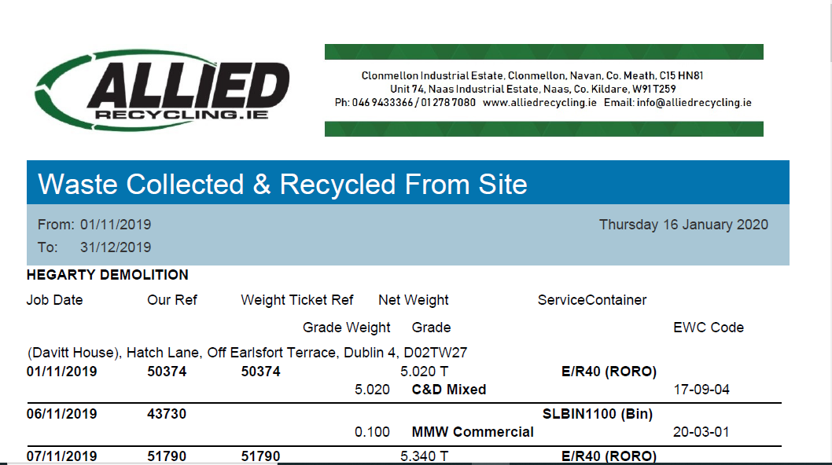

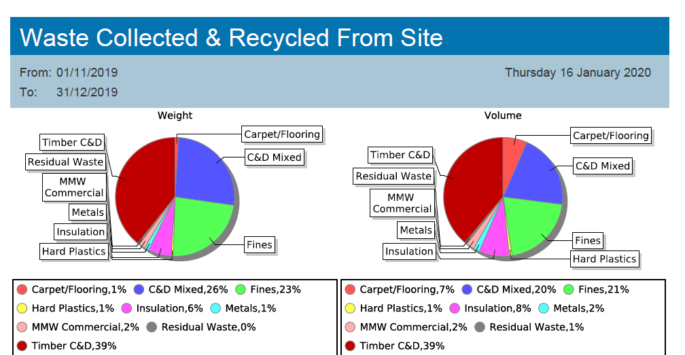

Section 7: Noise Dust and Vibration Control

Restrictions on Noise

A full suite of Noise/dust and Vibration monitoring will be implemented on site and phased into the works areas as they progress, full monitoring and reporting will be carried out by an appointed analyst where necessary. Hegarty demolition Ltd will ensure all noise levels in the working area are assessed in detail (as per risk assessment & Environmental Impact & Site limitations document) within the grant of Planning conditions with the relevant appropriate action to reduce the noise emissions and in conjunction with the Safety Health and Welfare at Work (Control of Noise at Work) Regulations 2013. Site management will be aware and conscious of noise levels on the site due to the proximity to local business. HDL shall as be reasonable as practical minimize and reduce the levels of noise in accordance with best practice guidelines provided in B.S 5228 – Code of Practice for Noise and Vibration control on Construction and open sites and the measures outlined in the EIA Documents previously submitted as part of the planning application. Noise levels will be monitored around the site, consideration will be given to residents. HDL will only make noise on site during the planning permission hours of the site. Acoustic Barriers will be set up around the work area to prevent sound travelling.

Restrictions on Dust
Hegarty Demolition Ltd will take all necessary measures to reduce any dust emission on site. The environmental Impact for Dust will be considered while reducing all levels of dust.
Hegarty demolition Ltd will ensure all noise levels in the working area are assessed in detail (as per risk assessment & Environmental Impact & Site limitations document) & Item 11 (a) within the grant of planning conditions.

All dust levels will be monitored by site management. Dust Suppression e.g., water hoses located at the source of the works keep down the dust levels during demolition. Operatives will be wearing masks in the area.
Stockpiles that may give rise to dust emission will be wetted down throughout for the duration of the works. Dust monitors will be in place around the demolition area and the levels checked. HDL will monitor levels of dust around the residents to see if dust levels are high. Acoustic Barriers will be set up around the work area to prevent dust spreading to neighbouring buildings.

Restrictions on Vibration
Hegarty Demolition Ltd will ensure that prolonged use of vibrating equipment will be avoided. All machinery will be frequently serviced and maintained and ensured it is off safe use.

HDL shall as reasonable as practical minimize and reduce the levels of vibration in accordance with best practice guidelines provided in B.S 4142.

Hegarty Demolition management will monitor the health and safety while vibrating equipment is being used. Workers using equipment will be rotated and will wear anti vibration gloves during works.

SECTION 8: TRAINING & Awareness

Copies of the Waste Management Plan will be displayed in the site offices for referral by site operatives. Environmental issues, site rules and waste management arrangements will be discussed as part of the Site Safety Induction, which all site personnel must attend. Toolbox Talks will also be held periodically to inform employees of their responsibilities under the plan and current waste management legislation.

SECTION 9: WASTE AUDITING

To ensure quality, effectiveness and efficiency, Hegarty Demolition implement a Quality Environmental Management System (QEMS) (ISO 14001 approved) on all projects. Key implements of this QEMS include:

• A regime of internal and external audits, consisting of a systematic study of all waste management practices which have been adopted on-site.

• Monthly environmental audit, which will highlight corrective actions that will be taken in relation to management polices of site practices in order to bring about further waste reductions.

• Waste walks, part of our approach to the project, will be carried out to identify opportunities for waste reduction.

The Site Manager or the Waste Coordinator shall arrange for full details of all arising, movements and treatment of waste to be recorded. Each consignment of waste taken from the site will be subject to documentation, which will conform to the waste manifest attached and ensure full traceability of the material to its destination.

The amount, nature and composition of the waste generated on the site, will be logged in the waste log as shown above. This information can then be used to examine the way the waste is produced and provide a commentary highlighting how management policies and practices may inherently contribute to the production of waste.

