South Dublin County Council,
Land Use, Planning and Transportation Department,
County Hall,
Tallaght,
Dublin 24,
D24 YNN5
07th February 2022
Planning Compliance Submission
Conditions: No.3,4,5,6 & 7

Planning Reg Ref No: SD 19A / 0264
Final Grant Order No: 1245
Site Location: Jordanstown Road,
Aerodrome Business Park,
College Land,
Rathcoole,
Co. Dublin.

Description of Development: The development will comprise of the provision of a warehouse with ancillary three storey office and staff facilities and associated development. The warehouse will have a parapet height of 17 metres with a gross floor area of 14,649 sq m including warehouse area (13,494 sq m), ancillary office areas (1,099 sq m) and staff facilities (56 sq m).
The development will also include: the provision of new vehicular access/egress and a separate HGV access/egress onto the Jordanstown Road; internal roadways; pedestrian access; 152 No. ancillary car parking spaces; bicycle parking; HGV yard including 26 No. HGV parking stands and 18 No. loading docks; hard and soft landscaping including green walls; lighting; photo-voltaic panels; ESB substation and switch-room; plant; boundary treatments and associated development works above and below ground.

To whom it may Concern,
Dear Sir or Madam,
On behalf of our Client, IPUT Plc, we wish to submit the enclosed (5 x Copy) documentation to South Dublin County Council for approval covering Conditions 3,4,5,6 &7 and as explained here in.

Condition 3
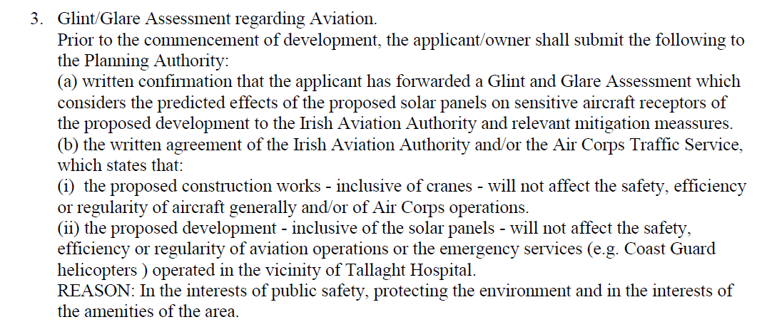

Response:
Please refer to document (Unit Q2 Aerodrome Business Park- GGA) and (Appendix A -forgesolar-aviation -report-210916-0805-83) attached which confirms that a glint and glare assessment has been carried out and that the predicted effects of the proposed solar panels will not affect the sensitive aircraft receptors of the proposed development. Please also find enclosed correspondence between MAC and the Irish Aviation Authority, whereby they have asked us to submit the glint and glare assessment to the property management branch of the department of defence so that they can assess any potential impacts and determine whether any alterations need to be carried out to safeguard the safety of the aircraft’s crafts in operation. The department of defence responded to confirm that based on the results of the Glint and Glare and Zone of Theoretical Visibility analyses that MAC carried out, the Irish Air Corps is satisfied that the proposed development inclusive of solar panels will not affect the safety and efficiency of the aviation operations at Casement Aerodrome. The Irish Aviation Authority also asked us to submit the glint and glare report to Colm Megan in the HSE.

Condition 7
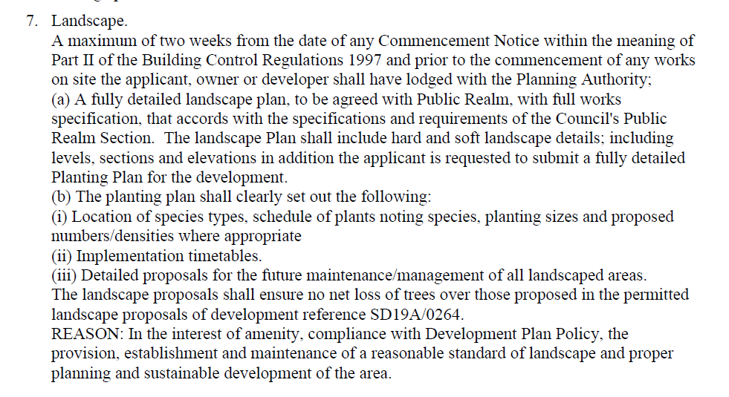
Response:
Please refer to drawing BIH -JBAI-XX-XX-DR-L-0001-LM (Landscape Masterplan), which includes the hard and soft landscape details level, sections, and elevations in addition to the planning plan. The (planting plan) BIH-JBAI-XX-XX-DR-L-0002 outlines the location and types of the species along with a schedule noting the number and size of the planting species. Also attached is (softworks landscape specification) BIH- JBAI-XX-XX-RP-L-0001 that recommends when these plants and species should be implemented and how they should be maintained.

Condition 4,5&6
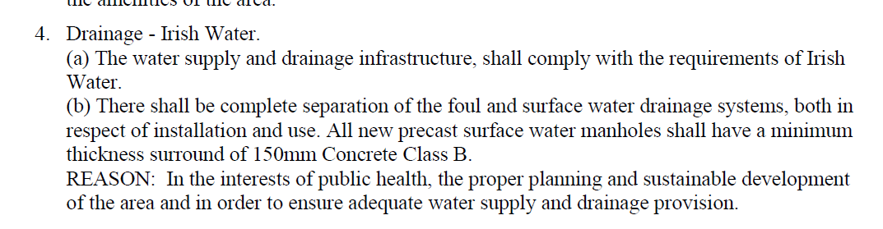
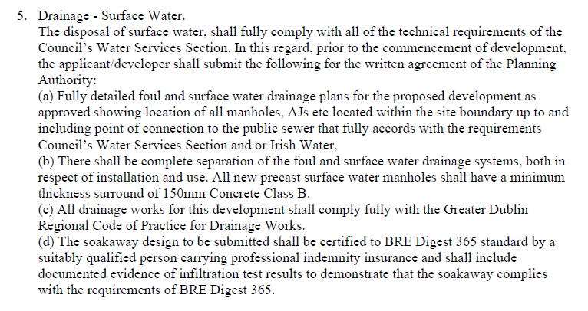
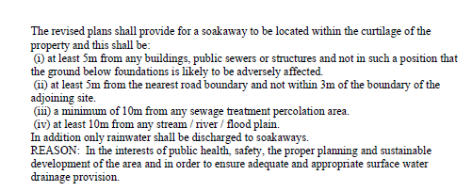
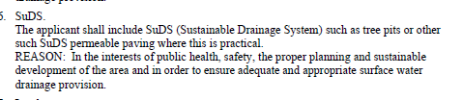

With reference to the above planning permission, OCSC confirm that the amendment made to the parent
planning application SD21A/0276 has no drainage characteristics or proposals
attached to it therefore no response needs to be submitted for conditions 4, 5 & 6.

We trust these submissions meet the requirements of The Authority. Our client would be most obliged if the Council can acknowledge acceptance of same at their earliest convenience.

Yours Faithfully,

____________________________

For and on behalf of
c/c IPUT Plc.

