Aerodrome Manager, Date: 02/08/2022
Casement Aerodrome,
8H55 + JF Baldonnell,
County Dublin
Re: Construction Activities & Crane Usage Vicinity of Casement Aerodrome.

Dear Sir / Madam,
My name is Peter Sharpe and I work on behalf of B&C Contractors Monahan Ltd as their EHS manager and Appointed Person, I am writing to advise of our intention to commence construction activities in the vicinity of Weston Aerodrome. During the course of our activities, we intend to make use of several self-erect tower cranes throughout the site. The actual date for erection of cranes is as yet unknown, however I wanted to establish communication at an early stage. Please see below some details that are known at this stage.
Site location: 53.341707, -6.475181 (centre of site)
Aderrig Phase 2 (Linear Park)
Adamstown, Lucan, Dublin
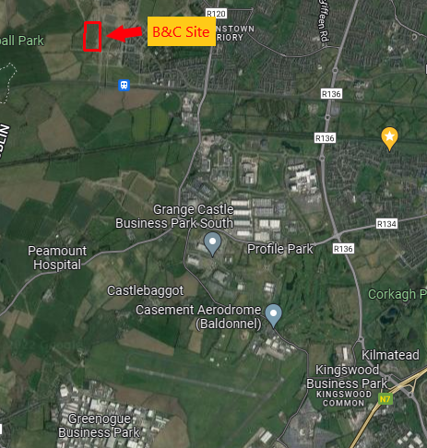

Max Height of Crane (AGL): 25 meters (normal operations) +56m AOD (Malinhead)

Crane type: Mantis 35.10 Self Erect Crane
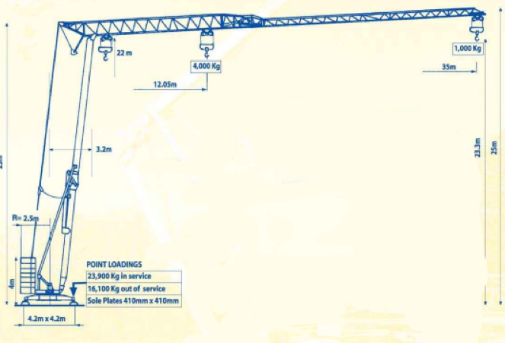
Max Radius of Crane: 35 meters
Dates of operation: 01/09/2022 – 02/02/2024
Contact details:
Name | Position | Phone Number | Email
Peter Sharpe | EHS Manager B&C | 0857340847 | Peter.sharpe@bandccontractors.ie
Colm Mc Bride | Company Director B&C | 0872644068 | Colm@bandccontractors.ie
Paul Babington | Site Manager B&C | 0876599687 | Paul@bandccontractors.ie
Paul Gribben | Site Engineer B&C | 0879416015 | paul.gribben@bandccontractors.ie

Many thanks and regards,
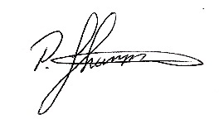
Peter Sharpe Dip ohs M.Sec.ii
Environmental Health & Safety Manager
B&C Contractors Monaghan Ltd,
Church Street, Carrickmacross, Co. Monaghan.
Tel: +353 42 9661124, Mob: 085 7340847
website: www.bandccontractors.ie Email: Peter.Sharpe@bandccontractors.ie

