1st Floor, Block A
Citywest Shopping Centre
Dublin 24,
D24 K0YT

T +353 1 253 0710
E info@pmep.ie
www.pmep.ie

South Dublin County Council,
Planning Department,
County Hall,
Tallaght,
Dublin 24.
D24 YNN5

E: planningdept@sdublincoco.ie
Date: 17th May 2023
Dear Sir/Madam,

RE: DETAILS OF COMPLIANCE WITH CONDITION NO. 13 OF THE PERMITTED WAREHOUSING / LOGISTICS, OFFICE AND CAFÉ / RESTAURANT DEVELOPMENT AT CALMOUNT ROAD AND BALLYMOUNT AVENUE, BALLYMOUNT INDUSTRIAL ESTATE, DUBLIN 12

SDCC REG. REF.: SD22A/0099

Condition No. 13 – Public Lighting

Introduction

On behalf of the applicant, Blackwin Limited, The Herbert Building, The Park, Carrickmines, Dublin 18, we hereby submit a compliance submission in respect to Condition No. 13 of Reg. Ref.: SD22A/0099 for which the final grant of permission from the Planning Authority is dated the 3rd of February 2023.

The permission relates to inter alia the construction of five no. warehouse/logistics units, 3 no. own door office buildings, a café unit, and all associated development.

This submission, as outlined below, relates to Condition No. 13 only and is submitted in soft copy format only.

Condition No. 13 reads as follows:

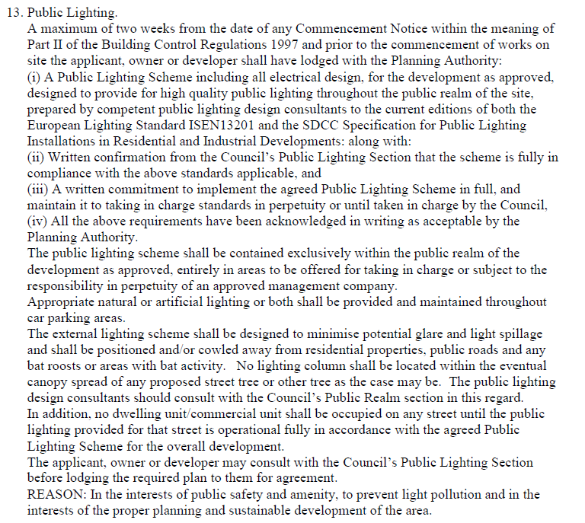

Response

In response to the foregoing condition, this cover letter is accompanied by various documents that were submitted to the Public Lighting Office, of the SDCC Land Use, Planning and Transportation Department, for review, comment and pre-approval pertaining to the public lighting design and installation associated with construction of the logistics / warehouse, office and café/restaurant development at Calmount Road and Ballymount Avenue, Ballymount Industrial Estate, Dublin 12.

The snip it below, has reference to email correspondence from Gráinne Mowlds, Executive Engineer, SDCC Public Lighting, confirming satisfaction and acceptance that the Public Lighting design is in line with the requirements of the SDCC Public Lighting Specification.

We would be grateful if the Planning Authority could consider and confirm that this compliance submission is satisfactory to address the prior to commencement requirement of Condition No. 13.

Conclusion

Response form Gráinne Mowlds:
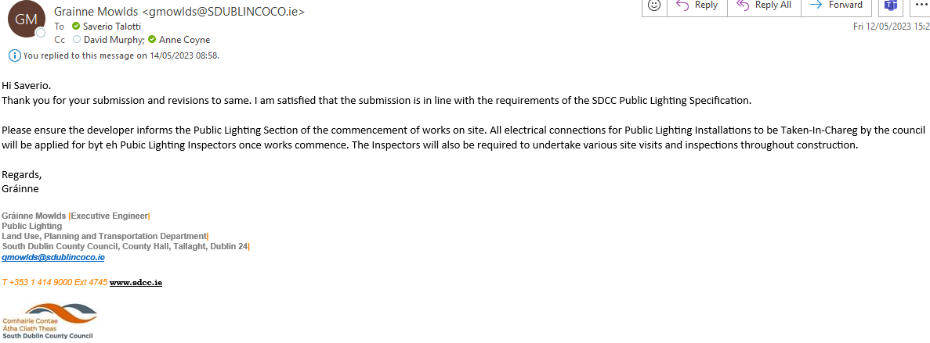

Please do not hesitate to contact us if you require any additional information or clarification in respect to the above.

Yours sincerely,

Saverio Talotti

